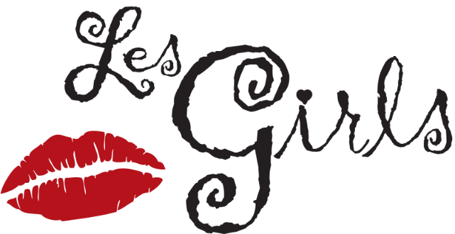
Honoring Alec Call & Bryan Johns
Advocacy Award: Sherry Goldman

SAVE THE DATE
Sunday, October 24, 2021
6:00 P.M. Cocktails, Hors d’Oeuvres
7:30 P.M. Cabaret
An evening of celebration to benefit
THE NATIONAL BREAST CANCER COALITION FUND
Event Committee:

Gerry Bernardi and Joe Keenan • Alec Call and Bryan Johns • Linda Essakow • Sherry Goldman • Lonnie Israel • Blake Johns and Brit Shaw • Pamela Morton • Lauren Shuler Donner • Arleen Sorkin • Carol and Terry Wall.

To purchase sponsorship packages, journal ads, and tickets, or for more information, contact Sharnita Goins at 1-800-320-0803 or NBCCEvents@stopbreastcancer.org.

